The CIS Department Student App will be a one-stop shop web app for CIS student needs relating to the department. It will keep track of an individual student’s pre-professional and professional program GPA and the status of the student’s professional program application. It will have information about the student’s advisor, how far along they are in their degree program, and allow the student to fill out the professional program application automatically.

Optionally, we may integrate information on students’ CIS accounts and Beocat account. Also in consideration is a calendar for 018/015 events that are coming up along with tracking of 018/015 credit.

Our stakeholders are CIS students in the Pre-Professional and Professional programs, CIS department faculty and staff, and advisors to these students. Initially, we will be looking to redo the professional application backend to prepare the student webapp for use, since there has already been some work completed in that area. Once we have completed that, our next goal is to attach the existing code to the new application backend. We will then move to develop the front-facing experience.

After project completion, it will be maintained by CIS faculty and staff.

For the front end, we will be using React JS, as the previously built parts of the project already use that library. For the back end, we will be working with NodeJS and SQL (PostgreSQL) to interact with KSIS and organize the students’ data.

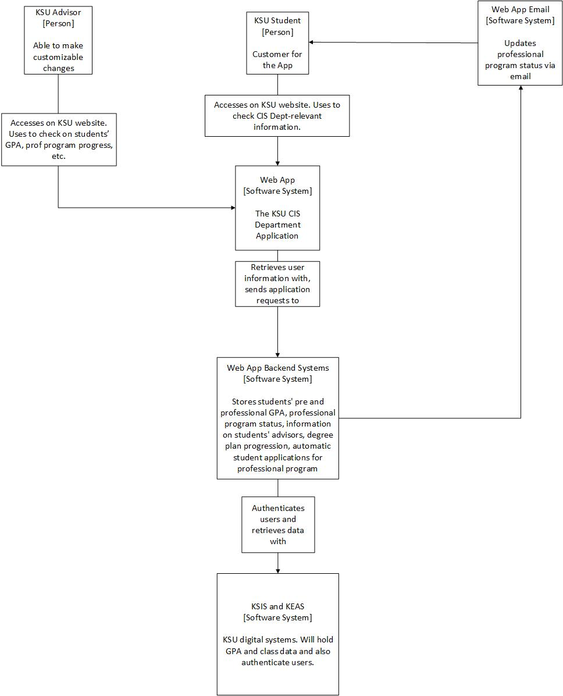

In the figure above, you can see that we will have customers go through KSU webpages to get to the website, where they will be able to view their information and submit applications. Not pictured is the fact that they will need to go through KSU’s SSO to get onto the pages first.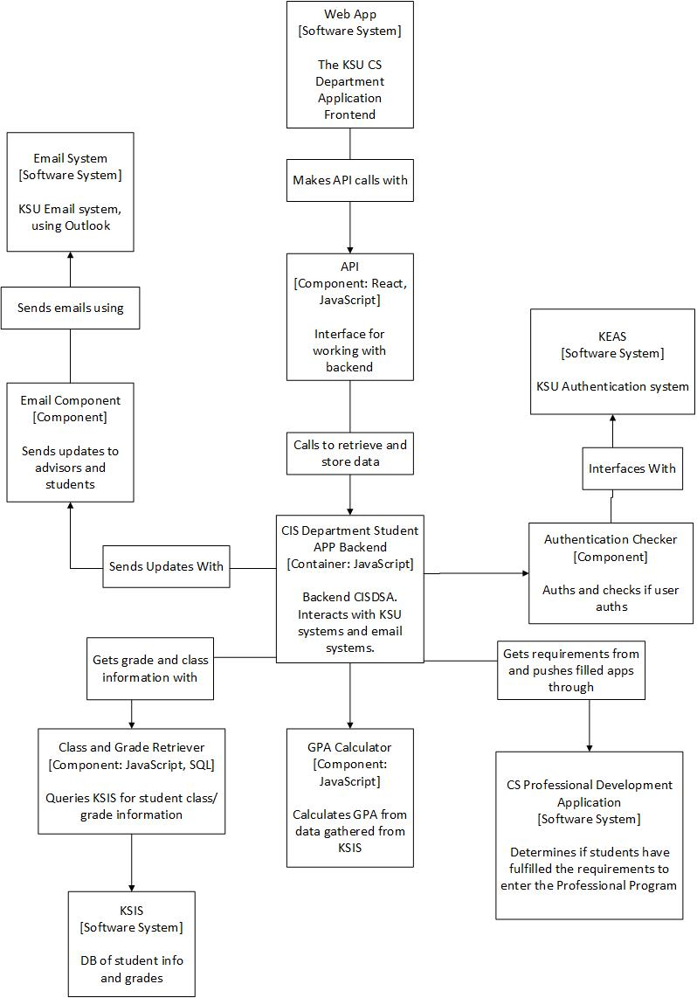

Per the figure above, we are going to be initially sending customers through KEAS and then we will query their grade/class information from KSIS with SQL. We can then compare the data with requirements pulled from the application and then allow students to submit professional applications.